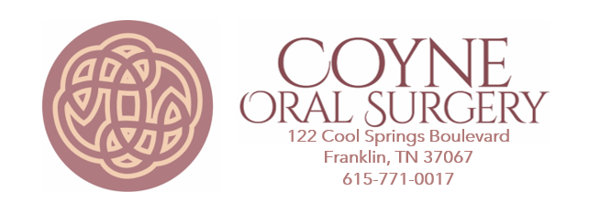

**CONSENT TO CONTACT**

COYNE Oral Surgery and anyone contacting you on our behalf may contact you for any purpose and in any matter permitted by law. You also expressly consent to be contacted by Coyne Oral Surgery, and anyone contacting you on our behalf, for any purpose, including billing, collection or any other account or service related purpose, at any telephone number or physical or electronic address where you may be reached, including any wireless telephone number.

Coyne Oral Surgery and/or anyone contacting you on our behalf may contact you in any way, such as calling, texting, emailing, sending mobile application push notification, or using any other method of communication permitted by law. You agree that Coyne Oral Surgery and anyone contacting you on our behalf, may communicate with you in any manner, including through the use of an artificial or pre-recorded voice message or an automatic telephone dialing system. We may contact you on a mobile, wireless or similar device, even if you are charged for it.

Thank you.

-------------------------------------------------------------------------------------------------------------------------------

Print Name

------------------------------------------------------------------------- ---------------------------------------

Signature Date